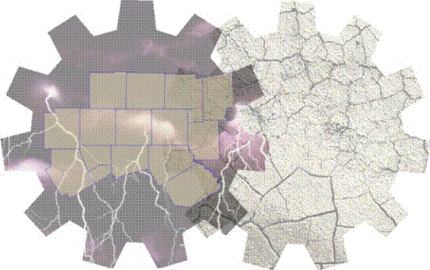
Floodplain Verification Form
North Central Texas Safe Room Rebate Program

Date: ____________

Applicant Information:

Name (one name only): _________________________________________________________________

Address: _____________________________________________________________________________

City: ___________________________ State: _________________ ZIP code: __________________

Email address: _______________________________________ Phone number: ___________________

Local Floodplain Representative (LFR) Information:

Name: _______________________________________ Title: __________________________________

Email address: _______________________________________ Phone number: ___________________

Latitude and Longitude of above property (must be to 5 decimal places):

____________________________________________________________________________________

LFR Signature: ________________________________________________________________________

I, as a Local Floodplain Representative for my jurisdiction, verify that that according to the maps provided by the National Flood Insurance Program (NFIP) and available to the local entity, the property listed above does not appear to be in the Special Flood Hazard Area (SFHA) or in a designated FEMA Flood Zone A or AE. I do not verify the establishment or confirm the location of SFHA floodplain areas with respect to property limits or structures.

Note: SFHA's on NFIP maps are not a guarantee that any particular location is not subject to inundation, only that it is denoted as reasonably safe from flooding.

